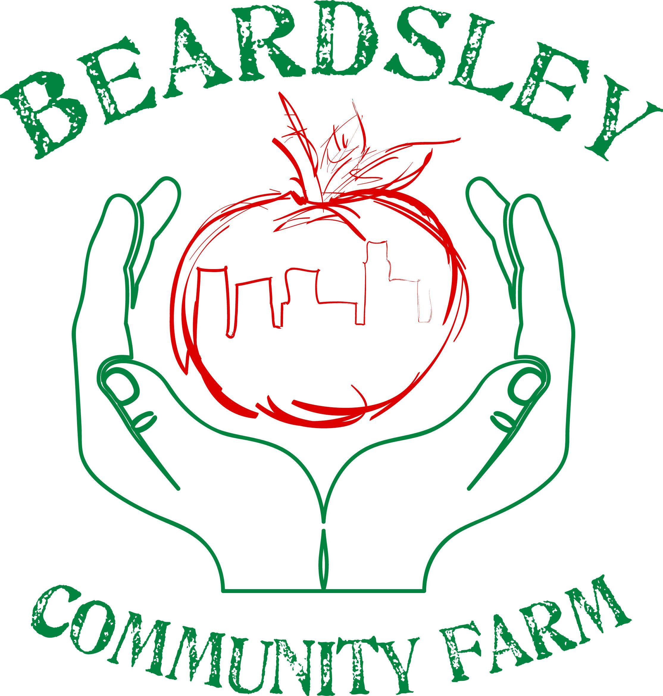
About CAC Beardsley Community Farm

CAC Beardsley Community Farm is an urban demonstration site that promotes food security and sustainable urban agriculture through practice, education, and community outreach. We were founded in 1998 to provide fresh, sustainably grown produce to people in need. Today, all of the fruits and vegetables raised at CAC Beardsley Farm are donated to local food pantries, food kitchens, and other charities. We also educate people of all ages about the possibilities and methods of organic and sustainable urban gardening. By giving support and tools to community members, we help them grow their own food and learn about the financial and environmental benefits of home food production.

WorkShare CSA Information

The CAC Beardsley Community Farm CSA (Community Supported Agriculture) WorkShare program allows individuals to earn food by volunteering at the farm. We are looking for enthusiastic and open-minded applicants who wish to supplement their weekly groceries with fresh produce. No previous gardening experience is required but it is welcomed!

By volunteering for four hours, participants earn a full box of food (a share). CSA members may earn a share weekly or monthly depending upon the amount of volunteering per week that their schedules allow. However, in order to maintain membership, CSA members must volunteer for a minimum of four hours a month.

Contact the farm to determine your start and end date. All applicants must be 18 years or older. Only one share per household, but all household members may contribute hours towards the share.

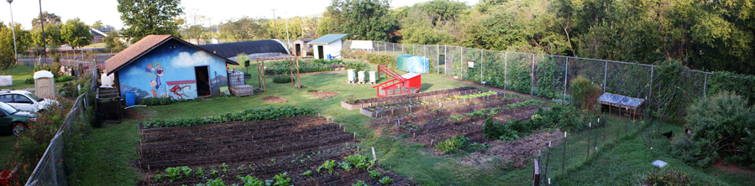

To contact CAC Beardsley Community Farm:
Call 865-546-8446 or email beardsleyfarm@gmail.com

2018 WorkShare CSA Application

CAC Beardsley Community Farm’s WorkShare CSA slots are assigned based upon the following criteria: previous participation in Beardsley’s programs and proximity to the farm. Our goal is to create a thriving garden that increases food security for local residents.
Please fill out ALL of the following information and
mail it to CAC Beardsley Community Farm PO Box 51650, Knoxville, TN 37950
or email it to beardsleyfarm@gmail.com

Name:_______________________________ Phone Number:_________________________

Address:________________________________________________________________________

________________________________________________________________________________

Email Address (if applicable):_______________________________________________________

Preferred Method of Contact:_______________________________________________________

Did you participate in any of Beardsley’s programs last year? Circle all that apply.

COMMUNITY GARDENS | WORKSHARE CSA | VOLUNTEER | NONE

Please circle the type of share you are interested in:

FULL SHARE | HALF SHARE | EITHER

Please circle how often you would like to receive a share:

WEEKLY | BI-WEEKLY | MONTHLY
Which months do you plan to participate in the program? Mark those that apply with an X.

Spring |  |  | Summer |  |  | Fall
Mar | Apr | May | June | July | Aug | Sept | Oct | Nov

Please indicate the times you are available to work in the gardens to the best of your ability. CSA members must be available at least one weekday between 9:00am and 3:00pm during the spring and fall, and between 8:00am-12:00pm in the summer.

Monday | Tuesday | x | Thursday | Friday | Saturday | x

What plants are you interested in tending this year?

________________________________________________________________________________

________________________________________________________________________________

Why do you want to garden this year?

________________________________________________________________________________

________________________________________________________________________________

________________________________________________________________________________

________________________________________________________________________________

Have you gardened before? When?

________________________________________________________________________________

________________________________________________________________________________

What would you like to learn this year? Are there any garden classes that interest you?

________________________________________________________________________________

________________________________________________________________________________

________________________________________________________________________________

________________________________________________________________________________

How did you learn about CAC Beardsley Community Farm?

________________________________________________________________________________

________________________________________________________________________________

